Software Requirements Specification

for

Child Care Application
Version 1.01
Prepared by Nathan Graham
Brandon Fowler
Brain Lollis
Blaine Abbott
EWU Computer Science
01-15-2015
Table of Contents
Table of Contents ii
Revision History ii
1. Introduction 1
1.1 Purpose 1
1.2 Document Conventions 1
1.3 Intended Audience and Reading Suggestions 1
1.4 Project Scope 1
1.5 References 1
2. Overall Description 2
2.1 Product Perspective 2
2.2 Product Features 2
2.3 User Classes and Characteristics 2
2.4 Operating Environment 2
2.5 Design and Implementation Constraints 2
2.6 User Documentation 2
2.7 Assumptions and Dependencies 3
3. System Features 3
3.1 System Feature 1 3
3.2 System Feature 2 (and so on) 4
4. External Interface Requirements 4
4.1 User Interfaces 4
4.2 Hardware Interfaces 4
4.3 Software Interfaces 4
4.4 Communications Interfaces 4
5. Other Nonfunctional Requirements 5
5.1 Performance Requirements 5
5.2 Safety Requirements 5
5.3 Security Requirements 5
5.4 Software Quality Attributes 5
6. Other Requirements 5
Appendix A: Glossary 5
Appendix B: Analysis Models 6
Appendix C: Issues List 6

Revision History
Name | Date | Reason For Changes | Version
Brandon Fowler | 01-15-2015 | Initial Draft | 1.0
Brian Lollis | 01-18-2015 | Second Draft | 1.01
Brandon Fowler | 02-4-2015 | Additional Information | 1.02
Brandon $ Brian | 03-17-2015 | Corrections | 1.03

Introduction

Purpose
This SRS describes the software functional and nonfunctional requirements for release 1.0 of the Spokane Club Child Care Application(SCCCA). This document is intended to be used by the members of the project team that will implement and verify the correct functioning of the system. Unless otherwise noted, all requirements specified here are high priority and committed for release 1.0.

Document Conventions
Bold titles refer to a new section. Numbering for each section will start with the section number, followed by a dot and then subsequent subsection numbers.

Intended Audience and Reading Suggestions
This document is for use by the application developers and for the client, Spokane Club, to remain informed of project specifications.

Project Scope
The SCCCA will permit parents/users to check in/out their children to/from the Spokane Club child care center. This will also allow the managers/administrators to compile parent billing reports.

References
<List any other documents or Web addresses to which this SRS refers. These may include user interface style guides, contracts, standards, system requirements specifications, use case documents, or a vision and scope document. Provide enough information so that the reader could access a copy of each reference, including title, author, version number, date, and source or location.>

Overall Description

Product Perspective
This software is intended to replace the current pen and paper records for checking children in and out of the Spokane Club child care facility. This will expedite the billing process, and reduce resource expenditures.

Product Features
Feature will include functionality for checking in and checking out children, compiling billing information, adding pictures of children and guardians, special events, and registering new children.

User Classes and Characteristics
This software is intended to be used by parents to check children in and out of the system. It will also be used by an administrator to register new children, set up special events, and compile billing reports.

Operating Environment
The application is being developed to be run on Windows 7, 8, and 8.1 based machines including desktops, laptops, and tablets. The operating environment will include tools such as a SQLite database, and the .net framework version 4.5. Development tools will include C#, and Visual Studio 2013.

Design and Implementation Constraints
Design of this software will need to protect against SQL injection. The client would like there to be multiple levels of administrative access, allowing some database changes to only be made by the top level administrator. Parents and administrators will be given separate forms for access to functionality.

User Documentation
We will be developing an accompanying document that will function as the user manual. Describing program functionality and procedures. The manual will be designed for entry level computer users.

Assumptions and Dependencies
It will be assumed that this software will be used in a windows environment. It will also be assumed that the system will be compatible with the .net framework and MySQL databases.

System Features

Manager Use
3.1.1 Billing Report
3.1.1.1 Description and Priority
Provide a report for all parental expenditures. This item is of high priority.

3.1.1.2 Stimulus/Response Sequences
<List the sequences of user actions and system responses that stimulate the behavior defined for this feature. These will correspond to the dialog elements associated with use cases.>
3.1.1.3 Functional Requirements
REQ-1: MySQL database connection
REQ-2: Allow managers to create reports for billing.
REQ-3: Allow managers to create invoices that will streamline the billing process.
3.1.2 Parent and Child Registration
3.1.2.1 Description and Priority
<Provide a short description of the feature and indicate whether it is of High, Medium, or Low priority. You could also include specific priority component ratings, such as benefit, penalty, cost, and risk (each rated on a relative scale from a low of 1 to a high of 9).>

3.1.2.2 Stimulus/Response Sequences
<List the sequences of user actions and system responses that stimulate the behavior defined for this feature. These will correspond to the dialog elements associated with use cases.>
3.1.2.3 Functional Requirements
REQ-1:
REQ-2:

3.1.3 Event and Fee Modifications
3.1.3.1 Description and Priority
<Provide a short description of the feature and indicate whether it is of High, Medium, or Low priority. You could also include specific priority component ratings, such as benefit, penalty, cost, and risk (each rated on a relative scale from a low of 1 to a high of 9).>

3.1.3.2 Stimulus/Response Sequences
<List the sequences of user actions and system responses that stimulate the behavior defined for this feature. These will correspond to the dialog elements associated with use cases.>
3.1.3.3 Functional Requirements
REQ-1:
REQ-2:

Parent Use
3.2.1 Check In Children
3.2.1.1 Description and Priority
A registered Guardian will be able to check a registered child into the system. The same guardian or another registered guardian, can then check the child out of the system. (High Priority)

3.2.1.2 Stimulus/Response Sequences
A registered guardian will be allowed to enter their user identification number and PIN number. Upon verification the guardian will then be allowed access to the check in screen, where they can select any child registered to them. They must first select an event, then will be allowed to select and check in children. This screen will also display all children that are logged in currently and registered to the guardian. The guardian will be able to select and log out any children visible.

3.2.1.3 Functional Requirements

REQ-1: Allow parents to make an account to use check in/out app.
REQ-2: Allow Parents to check in and check out their children.
REQ-3: Keep log of time children an checked into the Spokane Club child care service.
REQ-4: Keep log as children are checked in during special events.

External Interface Requirements

User Interfaces
Guardians will be provided a separate interface from administrators. Guardians will interact with a simple and natural, button driven user interface. Administrators will be provided more complex tools, necessary for entry or modification of system data and specifications.

Hardware Interfaces
The administration interface will be compatible with Windows desktop/laptop PCs. The guardian interface will be compatible with windows desktop/laptop PCs and Windows 8/8.1 tablet PCs. A server may also be necessary to host a MySQL database.

Software Interfaces
Both the guardian and administration sides of this software will interface with Windows 7 or higher, and a SQLite database.

Note: Remember Pictures here

Communications Interfaces
None

Other Nonfunctional Requirements

Performance Requirements
<If there are performance requirements for the product under various circumstances, state them here and explain their rationale, to help the developers understand the intent and make suitable design choices. Specify the timing relationships for real time systems. Make such requirements as specific as possible. You may need to state performance requirements for individual functional requirements or features.>

Safety Requirements
Sensitive data related to specific children will be protected from unauthorized users. Users will not be able to look up information on other parents or their children.

Security Requirements
User identification numbers will be verified as valid, and protected against unauthorized access. All database interactions will be protected against SQL injection. Sensitive information will be hashed to ensure if anything is found, it will be unusable.

Software Quality Attributes
<Specify any additional quality characteristics for the product that will be important to either the customers or the developers. Some to consider are: adaptability, availability, correctness, flexibility, interoperability, maintainability, portability, reliability, reusability, robustness, testability, and usability. Write these to be specific, quantitative, and verifiable when possible. At the least, clarify the relative preferences for various attributes, such as ease of use over ease of learning.>

Other Requirements
<Define any other requirements not covered elsewhere in the SRS. This might include database requirements, internationalization requirements, legal requirements, reuse objectives for the project, and so on. Add any new sections that are pertinent to the project.>
Appendix A: Glossary
<Define all the terms necessary to properly interpret the SRS, including acronyms and abbreviations. You may wish to build a separate glossary that spans multiple projects or the entire organization, and just include terms specific to a single project in each SRS.>

Appendix B: Analysis Models
Class Diagram:

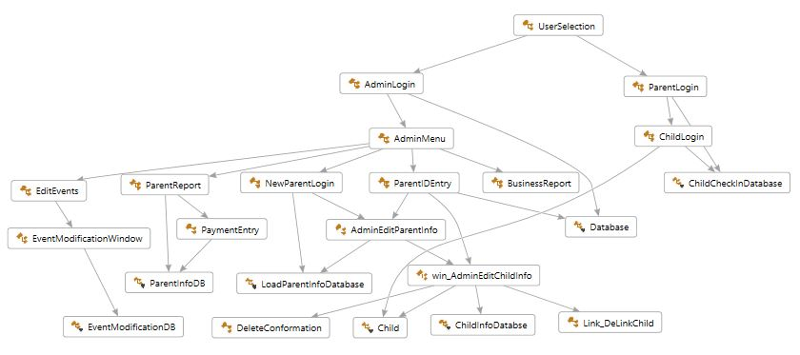

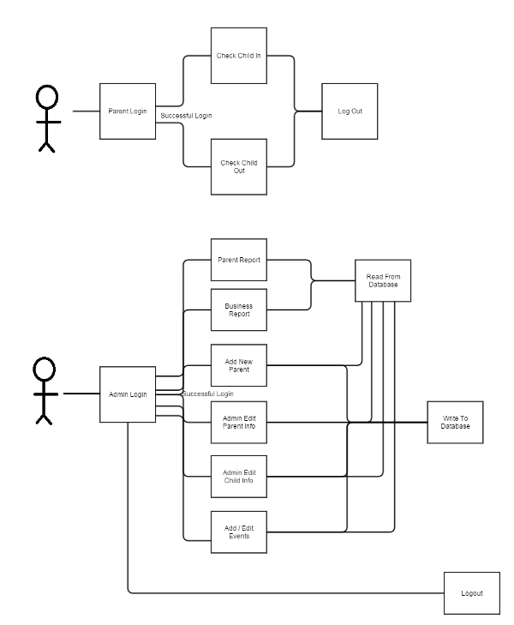
Use Case:

Appendix C: Issues List
< This is a dynamic list of the open requirements issues that remain to be resolved, including TBDs, pending decisions, information that is needed, conflicts awaiting resolution, and the like.>

